Monday in Holy Week
Jesus goes to the Temple
(Matthew 21 v 12-17)

Jesus went into the Temple and threw out all the people who were buying and selling there. He turned over the tables of those who were exchanging money or selling doves. Jesus said to all the people there, “It is written in the Scriptures, ‘My Temple will be called a house for prayer’, But you are changing it into a ‘hideout for robbers’” The blind and crippled people came to Jesus in the Temple and he healed them. The priests and teachers of the law saw what he was doing, and saw children praising God in the Temple. This made them angry, but Jesus said it was right for children to sing God’s praise.

Why was Jesus upset about people buying and selling there?
What should they have been doing in the Temple?

Prayer

Dear Lord, I’m sorry that often my behaviour isn’t as good as it should be. Please help me to think about what’s right and wrong before I act, and to praise you as much as I can. Amen

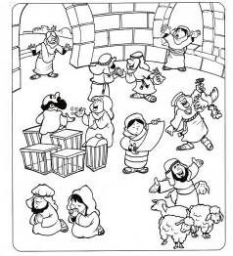
Tuesday in Holy week
Jesus teaches what’s most important
(Matthew 22 v.34-40)

The Pharisees didn’t like everything Jesus said, and some people tried to argue with him. One Pharisee, who was an expert on religious laws tried to test Jesus saying, “Teacher, which command in the law is the most important?

Jesus answered, “Love the Lord your God with all your heart, all your soul, and all your mind.’ This is the first and most important command. And the second command is like the first: ‘Love your neighbour as you love yourself.’ All the other laws and teachings depend on these two commands.”

Do you find it easy or difficult to keep these two commands?
Who do you think is your neighbour?

Prayer

Dear Jesus, Thank you for teaching us what’s most important. When I forget to love you and love other people as much as I can, please forgive me and help me to be more loving. Amen

Wednesday in Holy week
Judas betrays Jesus
(Matthew 26 v. 14-16)

One of the twelve apostles, Judas Iscariot, went to talk to the leading priests. He said, “What will you pay me for giving Jesus to you?” And they gave him thirty silver coins. After that, Judas watched for the best time to turn Jesus in.

Would you have betrayed Jesus for thirty silver coins?
When do you find it hard to stick by Jesus as your best friend?

Prayer

Lord Jesus, You are my best friend, but just sometimes I am tempted not to tell my friends how important you are to me. Next time I am tempted, please help me to stand up for you. Amen

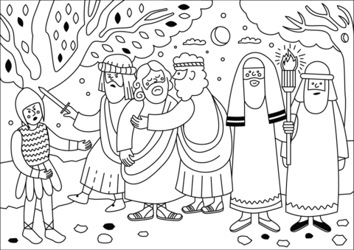

Maundy Thursday
Jesus has a last supper with his disciples
(Matthew 26 v. 17-30)

Jesus arranged for his followers to prepare the Passover meal so that they could share it together. As they were eating at the table, Jesus said, “One of you will turn against me”. This made the followers sad. Each of them thought that it couldn’t be them, but Jesus knew who would hand him over to be killed.

While they were eating, Jesus took some bread, thanked God for it, broke it, and gave it to them to eat saying, “This is my body”. Then he took the wine and said, “Every one of you drink this. This is my blood, poured out for many to forgive their sins”.

Can you remember who was going to turn against Jesus?
Why did Jesus say that the bread and wine were his body and blood?

Prayer

Lord Jesus, I am sorry that you had to die, but thank you that you did it for me, so that I can be forgiven. Help me to remember that every day. Amen
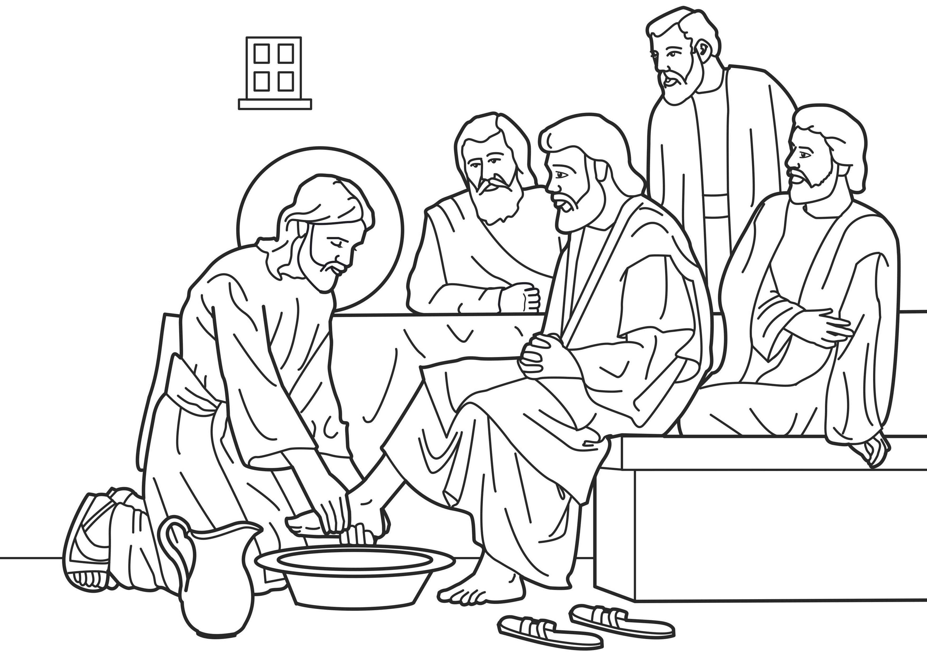

Good Friday
Jesus dies
(Matthew 27 v. 32-61)

Soldiers bullied Jesus. A man called Simon was forced to carry the cross for Jesus. When they got to a place called Golgotha (which means ‘Place of the Skull’, the soldiers nailed Jesus to the cross and waited for him to die. They put a sign above his head that said, ‘THIS IS JESUS, THE KING OF THE JEWS’’. Two robbers were crucified beside Jesus, one on either side of him. People walked by and made fun of Jesus. At noon, the whole country went dark for three hours. At about three o’clock, Jesus cried out in a loud voice and died. His mother and some of his followers were there, standing at a distance.

How does it make you feel when you hear about how Jesus died?

Prayer

Father God, Today is a very sad day. The only good thing about it is that you love us so much, and that’s why you sent your Son to die for us. Thank you for loving us that much. Amen

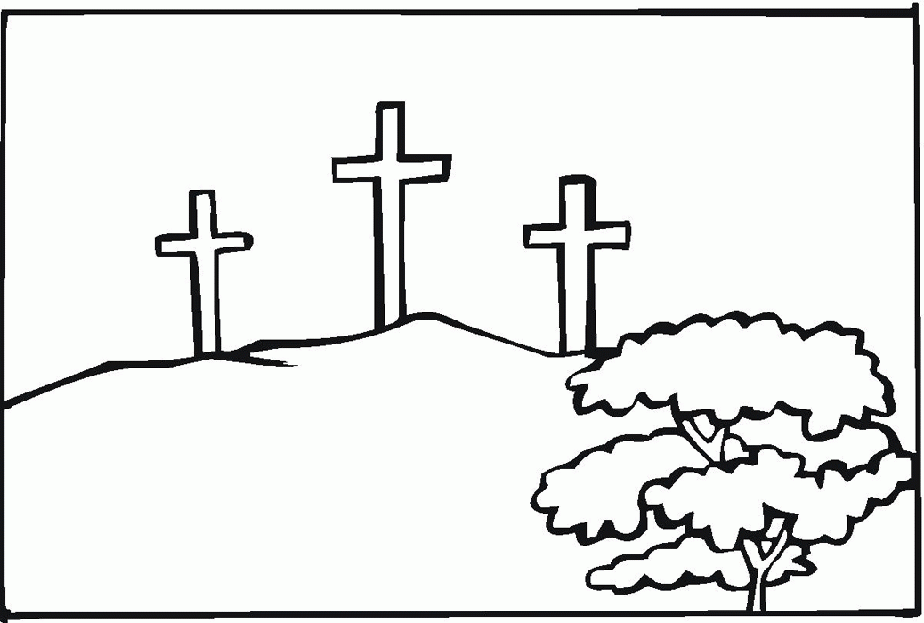

Easter Saturday
Jesus remains buried in the tomb
(Matthew 27 v. 62-66)

The day after Jesus died, the leading priests and the Pharisees went to the governor, Pilate. They asked him to make sure that the tomb where Jesus was buried would be guarded closely. They didn’t want any of his followers to steal his body and claim that he had risen from the dead. Soldiers went to the tomb with the priests to make sure that the stone in the entrance could not be moved, and the soldiers stayed there to guard it.

Some people still didn’t believe that Jesus really was God’s son, but they were suspicious of Him. Do you know anybody who finds it hard to trust that Jesus is real and that His story is true?

Prayer

Dear Lord, it’s sad to think that not everybody believes in you. Please help my friends to trust you. If there is anything I can do to help them believe, then please show me how to help. Amen

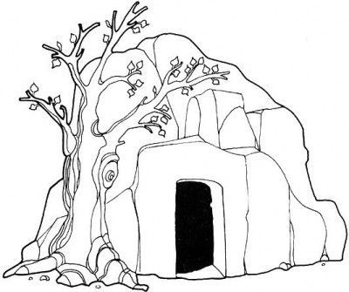
Easter Sunday
The best day ever! Jesus lives!
(Matthew 28)

Mary Magdalene, and another woman name Mary, went to look at the tomb. There was an earthquake, and an angel from heaven went to the tomb and rolled the stone away from the entrance. Then he sat on the stone and said, “Don’t worry, I know that you are looking for Jesus, who has been crucified. He is not here. He has risen from the dead as he said he would. Come and see the place where his body was. And go quickly and tell his followers, ‘Jesus has risen from the dead!”

The woman left the tomb quickly. They were afraid but they were also very happy! They ran to tell Jesus’ followers what had happened. Suddenly, Jesus met them and said, “Greetings!”

What is the best news you have ever had? Is it better than this good news? It can’t be!

Prayer

Dear Jesus, I’m so happy that you came back to life. Nobody can beat death, except you - you’re amazing! I’m going to praise you on this very special day, and tell my friends what happened!

